Welcome to APES! Whatever our school year looks like in the fall, I am excited to work with you and explore everything associated with understanding the complicated relationship between human beings and our planet. We will talk about economics, politics, anthropology, national and international law, intergovernmental and global cooperation, and so much more.

To prepare for our semester together, there are five things I would like for you to do this summer:

1. Join our Canvas course (where you will have access to learning modules for the year) by going to **https://gcs.instructure.com/enroll/P7YLCB**

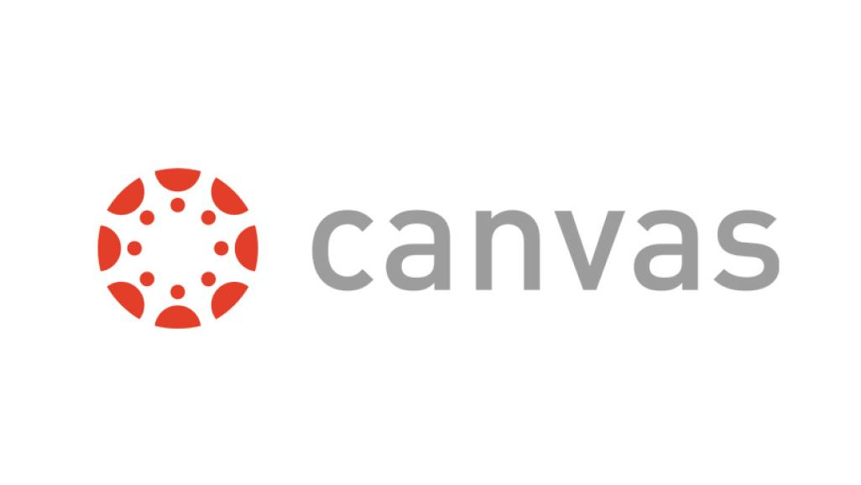

1. Watch the short (approximately 22 minute) video entitled *The Story of Stuff* by Annie Leonard and The Story of Stuff project by going to <https://www.youtube.com/watch?v=9GorqroigqM>

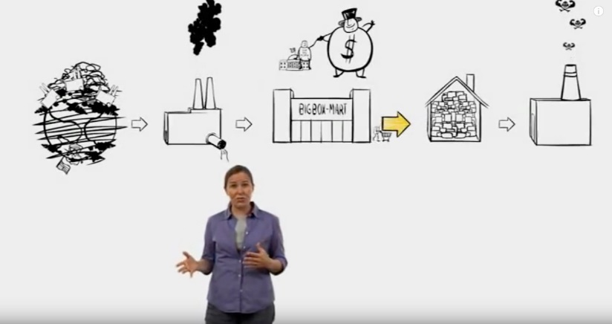

1. Complete the assigned essay—*The Story of Me and My Stuff—*based on the guidelines provided in Canvas. This isn’t research or complicated—it’s just to get you thinking!



1. Complete the *About Me* assignment in Canvas. It’s a quick Google Forms survey, so don’t panic! Please use your G-Suite (Chromebook login) account to respond!
2. Join the class Remind by texting the code @kingapes22 to 81810 or going to [https://www.remind.com/join/kingapes2](https://www.remind.com/join/kingapes20)2 Parents are welcome to join, too!

During the school year, we will be completing a book project organized around the book *World War Z: The Oral History of the Zombie War* by Max Brooks. Please get your own copy of this (either hard copy, digital, or audio book—whichever you prefer) and have it ready for the start of the semester. An online version will be shared on Canvas, but it is not the easiest to read. **You don’t have to read it over the summer, we will be reading it in sections together.** There is a film starring Brad Pitt that was ***loosely*** based on the book. It might help get you in the mindset, but it will not take the place of the actual book. Feel free to watch it as well.

I look forward to working with you next school year! I will be available to talk with you over the summer and may have some get-to-know-you sessions on the Canvas course as we get closer to the school year. Please keep an eye on your email for information from me as we get started!

In the words of two very wise men, Bill Preston and Ted Logan…



Mrs. King-Bennett